Occupational Specialism

Task 2 Development

Contents

Task 2: Designing the solution 1

Introduction 1

My proposed solution 2

Functional and non-functional Requirements 3

Functional 3

Justification 3

Non-Functional Requirements: 3

Data Requirements 3

Decomposition of problems 4

Design 4

Automated testing 6

Sprint 1 7

Review 7

Sprint 2 7

Review 7

Sprint 3 7

Review 7

Review of product 7

Improvements 7

# Task 2: Designing the solution

## Introduction

**Set task brief:**

The software development company you work for has secured a new contract to develop a digital solution for GibJohn Tutoring.

* GibJohn tutoring currently provides customers with:
* Face-to-face tutoring sessions
* Access to learning resources
* Support to develop understanding in different subjects

The client (owners of GibJohn Tutoring) would like to develop a digital solution that will:

* Provide interactive teaching and learning resources in a range of subjects
* Provide access to digital content to encourage wider learning
* Support and monitoring of learner progress.

The client has carried out some market research with existing customers and tutors to identify features that could be included in the digital solution. The potential features suggested by the client are:

* Collaborative teaching and learning tools
* Accessibility features to support a wide range of users
* A learning reward system
* Gamified learning

## My proposed solution

I have been asked to create a solution that will meet the client’s needs.

For my proposed solution I will be designing a website, that will be able to provide access to digital content to encourage wider learning, give support to develop understanding in different subjects.

I will also be implementing a live chat feature where can you speak to a tutor for any advice and help that you may need.

•To make the website I will be coding in HTML and JavaScript to implement some dynamic features on the page.

To include all users, I will be trying my best to focus on making the website as accessible as I can, this could range to a magnifier to enlarge the text on the screen all the way to colour blind settings.

Requirements:

* Live chat
* support to develop understanding in different subjects
* access to digital content
* Accessibility settings

To ensure that I will have enough time to fully develop the project I will be using a method called agile, agile uses sprints which is the bare minimum requirements needed for a working project, each sprint from then on will add more features working on the existing foundations.

If I am ahead of schedule I will attempt to add a way to talk face-to-face with a tutor using something

I will be splitting the project into 3 separate sprints, each focusing on their own aspects of the webpage, sprint 1 will be focusing on the main requirements of the webpage, however, will be the bare minimum as the other sprints will improve on the foundation.

I will be planning to use **HTML** to create the webserver to add some dynamic features to the page such as parallax text I will be implementing some JavaScript into it.

I will also be using **CSS** which is a stylesheet (to make the page look nice)

## Functional and non-functional Requirements

### Functional

|  |  |  |  |
| --- | --- | --- | --- |
| # | Requirements | How will I accomplish? | Acceptance |
| 1 | Website displays relevant information | Using HTML and JavaScript i will make a website | When i click load on the website it will open and allow me to access the website as a whole |
| 2 | Authentication of a user when he/she tries to log into the system. |  |  |
| 3 | Live chat |  |  |
| 4 | Support to develop understanding in different subjects |  |  |
| 5 | Accessibility settings |  |  |
| 6 | Access to digital content |  |  |

### Justification

|  |  |  |
| --- | --- | --- |
| **Requirements** | **How will I accomplish** | **Acceptance** |
| **Create useable website** | **Using HTML and JavaScript I will make a website** | **When I click load on the website it will open and allow me to access the website as a whole** |

### Non-Functional Requirements:

* The program can run.
* The program loads every time.
* Updated quickly.
* The program runs effectively.
* It performs well under stress.
* Updated security to protect users.
* No bugs/errors or very little on release.

## Data Requirements

The following data types will be used:

• Strings: used to store information such as login credentials, passwords, emails, and other text-related data.

• Floats: utilised to store decimal numbers, such as cash, because they are not whole numbers.

• Boolean: true or false to allow data to flow in and out at different times. Incorrect passwords, for example.

## Decomposition of problems

Problem 1 – make a system that can provided learning resources to the client

• Provide learning resources

• Fetch information.

• Display information.

## Design

I have made a quick wireframe outlining key aspects of the main page for the website, along top will be the navigation bar. This will contain a series of buttons one being a drop down to add some dynamic features to the webpage, in the top left corner will be the logo of the company.

In the top right I have added a magnifying glass to enable users with visual difficulties to increase the size of the font on the page, next to it is the settings button that will drop down allowing you to customise the page. This will include a dark mode and colour-blind setting.

Initially i thought of having a pop outside navigation bar using JavaScript, however I thought the overall design would be taken up by the side navigation bar and have decided to go for the standard type of navigation bar whilst still including some JavaScript within the top nav bar.

I have decided to add some buttons in the middle of the page that will take you to different subjects that you can choose from however this may change soon.

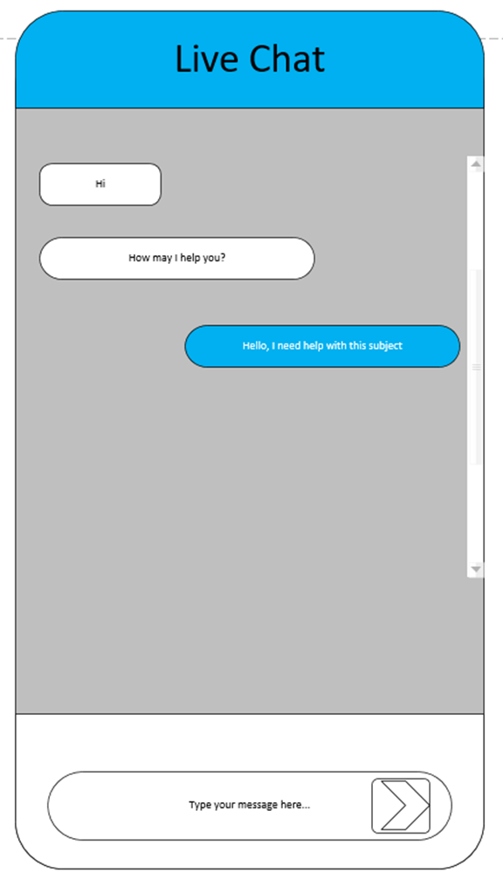

I have included a search bar so you can quickly and easily find what lesson you are looking for.

In the bottom right will be the button to contact the live chat, I have designed a quick wireframe for the design of the chat.

## Automated testing

Real users and manual testing aren't usually required. Stability and non-regression tests, as well as those performed with each new feature or modification, are examples of repetitive tests that can be automated.

• Reduce costs by lowering the amount of work that must be done manually.

• Make the most of your testing efforts.

• With a simple click, you can run dozens of tests to increase your coverage.

## Sprint 1

### Graphical user interface, website Description automatically generatedDesign

### Development

### Review

## Sprint 2

### Review

## Sprint 3

### Review

## Review of product

## Improvements